Monyetla Bursary Project

**Life Sciences: The Theory of Evolution**  **3 August 2024**

**Important Terminology** *(From Life Sciences Self Study Guide 5)*

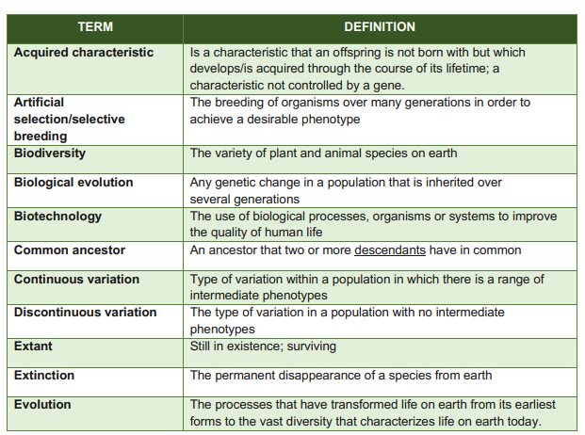

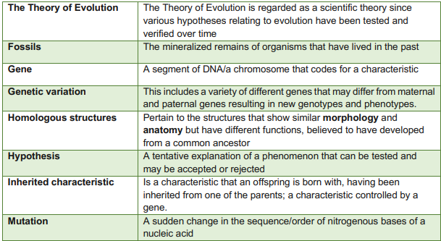

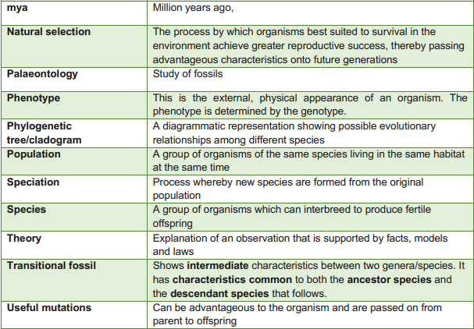

Paper 2 – May / June 2024

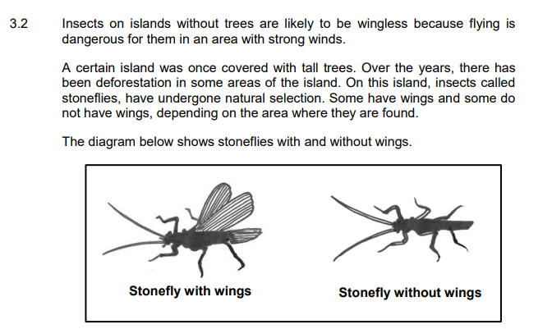

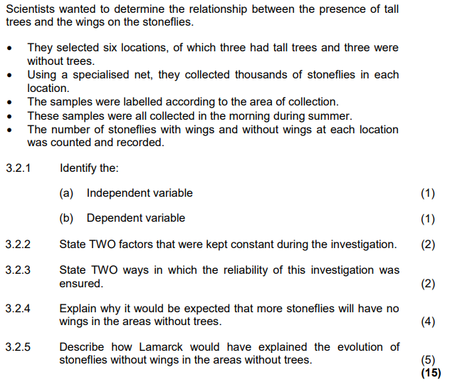



Paper 2 – May / June 2024 – Marking Guidelines

